Domain Model: Nudge

The Nudge application’s functionality mainly revolves around its User, who can navigate through groups they are a part of, to pages of questions that have been asked by coworkers in the group. This then allows them to post questions, read responses, and message users for further clarification on any questions. Beyond that, the user can unlock further permissions if given the role of an administrator, which grants them the ability to respond to flagged messages, review and remove messages, and also carry out moderation on users’ accounts. They can also invite users to groups within the app via the sendInvite() function.

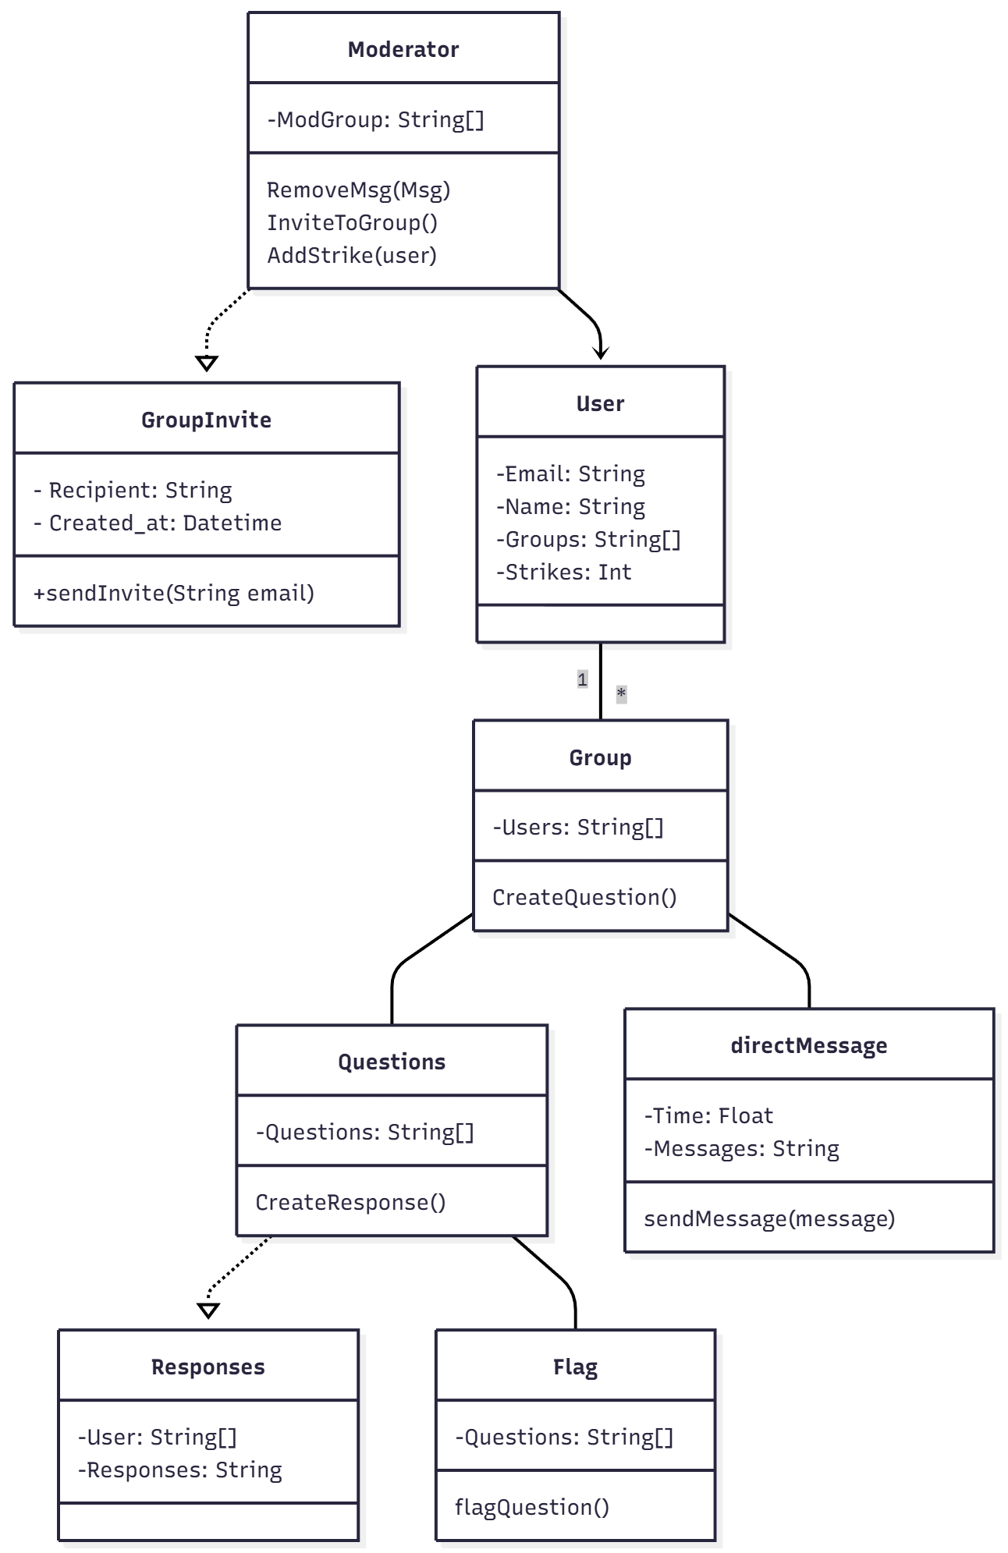
Nudge Mermaid chart

Object list:
- Moderator
  - ModGroup: String[]
  - RemoveMsg()
  - InviteToGroup()
  - AddStrike()
- GroupInvite
  - Recipient: String
  - Created_at: Datetime
  - SendInvite()
- User
  - Email: String
  - Name: String
  - Groups: String[]
  - Strikes: Int
- Group
  - Users: String[]
  - CreateQuestion()
- Questions
  - Questions: String[]
  - CreateResponse()
- Flag
  - Questions: String[]
  - FlagQuestion()
- Responses

  - User: String[]
  - Responses: String
- DirectMessage
  - Time: Float
  - Messages: String
  - SendMessage()

